Saudi Signage & Labelling Expo and Saudi Paper & Packaging Expo
2025 Factsheet
WHAT | The largest event for signage, labelling, paper and packaging industries in the Middle East  Saudi Signage & Labelling Expo is the largest event in the Middle East for the digital, print, graphic and imaging industries. Co-located with the inaugural edition of Saudi Paper & Packaging Expo, the events will explore the latest products, technologies and services shaping the signage, labeling, print and packaging industries.  Dates: 20 – 22 May 2025  Venue: Riyadh International Convention & Exhibition Center (RICEC)  Website: https://www.saudisignageexpo.com/
VIDEO | Teaser: https://youtu.be/MDyqE-ocPtc
WHERE | Riyadh International Convention & Exhibition Center (RICEC)
WHO | Organized by - dmg events (www.dmgevents.com)  Muhammed Kazi, Senior Vice President – Construction, dmg events  Samer Itani, Sales Director, dmg events  Fernanda Porto, Associate Vice President - Construction Marketing, dmg events
WHY | Saudi Signage & Labelling Expo, co-located with Saudi Paper & Packaging Expo, brings Saudi Arabia’s signage, labelling, print and packaging industries together. The Kingdom’s signage market is projected to reach $492 million by 2027 (Source: 360iResearch), while the paper and paperboard packaging sector is expected to grow to $2.84 billion by 2029 (Source: Mordor Intelligence).  Building on this momentum, the event offers unique opportunities for businesses to connect, explore sustainable innovations, capture emerging market potential and engage in a vibrant networking by bringing together key decision makers and industry players.
USPs | - Now bigger in size, the 2025 edition is the largest dedicated event for the signage, labelling, paper and packaging industries in Saudi Arabia, uniting 150+ global exhibitors and 14,000+ professionals under one roof.  - Attendees can witness live product demos, including car wrapping and labeling competitions, showcasing cutting-edge technologies.  - The event helps businesses tap into Saudi Arabia's rapidly growing market, offering opportunities to meet distributors and forge partnerships.  - The event highlights eco-friendly solutions and innovative technologies in signages, printing, paper recycling and packaging automation.
KEY STATS | - 2nd edition  - 150+ exhibitors  - 14,000+ visitors (expected)  - 15+ participating countries  - 1 co-located event – Saudi Paper & Packaging Expo
HIGHLIGHTS | Label It – A labelling competition where participants label as many products as possible within a given time period. The competition takes place from 20-22 May.
SPONSORS & PARTNERS | - Lanyard Sponsor – Al Rish Al Khaleej  - Badge Sponsor – CMYK Digital Solutions  - Supporting Association – Global Signage Alliance
SOCIAL MEDIA | LinkedIn | Facebook | Instagram | Twitter
OFFICIAL TAGS | #SSLE2025 #SPPE2025 #SignageExpo
Muhammed Kazi, Senior Vice President – Construction, dmg events  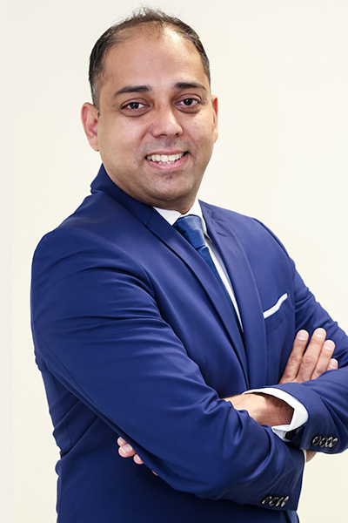 | Muhammed Kazi serves as the Senior Vice President – Construction at dmg events, where he spearheads events in the Kingdom of Saudi Arabia and Qatar. His primary focus involves growing and accelerating existing B2B events in Saudi Arabia while also exploring new acquisition and launch opportunities.  Muhammed has over 20 years of experience in the events industry in the Middle East, Africa and Asia. He has garnered extensive experience working closely with JV partners, one of which has seen the successful launch of the Intersolar brand in the Middle East. Muhammed has launched Big 5 Construct India, Big 5 Construct Indonesia, Intersolar Middle East, Windows, Doors & Facades, Rollers & Shutters Expo and Big 5 Construct Nigeria during his long-standing career at dmg events. He has also introduced high level conferences, launching the Global Solar Leaders’ summit and Future of Facades in the Middle East.  Having joined dmg events in 2008, Muhammed is an alumnus of the Preston University.
Mutaz Al Mazari, Event Director dmg events   | With over 15 years of experience in project and sales management, Mutaz Al Mazari has established himself as a seasoned professional in the industry. He transitioned into the exhibition and conferences sector in 2015, bringing with him a wealth of expertise and a strategic approach to event management. Since then, Mutaz has been at the forefront of orchestrating a diverse portfolio of high-profile B2B exhibitions.  Currently, Mutaz oversees some of the most significant international exhibitions in the infrastructure and industrial sectors within dmg events’ Saudi cluster of events. These include Global Infrastructure Expo, Saudi Warehousing & Logistics Expo, Global Water Expo, among others.

